## Movement System

The following information composes the justifications that were made to make a decision on the method of movement, more specifically the wheels of the entire system.

### Items Under Consideration

|  |  |  |  |
| --- | --- | --- | --- |
| **Item ID** | **Name** | **Vendor** | **Description** |
| 276-1447 | Mecanum Wheels | VEX Robotics | Four inch Mecanum wheels sold as a pack of four. |
| 276-3526 | Omni-Directional Wheels | VEX Robotics | 3.25 inch omni-directional wheels sold as a pack of four. |
| ROB-12124 | Heavy Duty Wheels | SparkFun | Four inch standard heavy duty wheels sold individually. |

Table X: Wheels under consideration for Roadie

### Decision Matrix

|  |  |  |  |  |  |  |
| --- | --- | --- | --- | --- | --- | --- |
| Factor | Cost | Ease | Stability | Mobility | Availability | Total |
| Weight | 0.1 | 0.2 | 0.15 | 0.45 | 0.1 | 1.0 |
| VEX Robotics Mecanum Wheels 4" | 2 | 4 | 5 | 5 | 5 | 4.5 |
| VEX Robotics Omni-Directional Wheels 3.25" | 3 | 4 | 4 | 5 | 5 | 4.45 |
| SparkFun Heavy Duty Wheels 4" | 4 | 2 | 2 | 3 | 5 | 2.95 |

Table X: Decision matrix for Wheels

|  |  |  |  |  |  |
| --- | --- | --- | --- | --- | --- |
| Factor | Cost per set | Ease (bore size) | Stability (wheel weight) | Mobility | Availability |
| 276-1447 | $59.99 | 0.125 inch square bar | 0.41lb | Can strafe | In stock |
| 276-3526 | $39.99 | 0.125 inch square bar | 0.1885lb | Can strafe | In stock |
| ROB-12124 | $27.96 | Unknown bore size | Unknown weight | Cannot strafe | In stock |

Table X: Quantitative and qualitative values of the line following sensors under consideration that led to the decision matrix.

### Justifications

#### Cost

The prices of each as a set of 4 wheels were as follows: The mecanum wheels are $59.99, the omni-directional wheels are $39.99, and the heavy duty wheels are $27.96.

Within the decision matrix, the scale was based so that 1 was the most expensive on the scale and 5 was the least expensive. A rating of 5 was measured as $80.00, a rating of 1 was measured as close to $0.00, and each rating in between was an increment of about $20.00.

#### Ease

The ease category related to the ease of assembling and mounting the wheels to the motor shafts. The heavy duty wheels have no information regarding its bore size. The VEX products do have this information as seen in the table above.

It also pertains to how easy the wheels would adapt to a different system design. Luckily enough, the mecanum and omni-directional wheels can easily act as standard differential wheels if a design change is made.

#### Stability

The stability of each wheel relates to how effective each will be on a consistent basis along with the weight of each wheel. Unfortunately, the heavy duty wheels do not list any weight. The VEX products do list their weights as seen in the table above.

It also considers if the width of each wheel is sufficient for the system, which each factor satisfies. The mechanum wheels rated slightly above the others because of the ability to make finer adjustments when moving near an obstacle.

#### Mobility

The mobility relates not only to the effects the wheels have when in coordination with the motor and the ground, but also to which axis of movement they can use. The mecanum and omni-directional wheels rated above the heavy duty wheels because of their ability to strafe.

#### Availability

The availability of each wheel relates to how easy the wheel and any possible repair/replacement parts are to obtain. SparkFun and VEX Robotics are both commonly known distributers, and one can obtain parts for each on a multitude of retail sites in addition to the SparkFun and VEX Robotics sites themselves.

### Overview

It seemed that the main factor when selecting the wheels came to be the price and mobility options. Current design options lean toward a system that can strafe. It is fortunate also that the mecanum wheels, which came out with the highest rating on the decision matrix, can be used in any design.

## Risk Analysis

This section will include information regarding risks related to the movement equipment and solutions to mitigate those risks. The probability of each occurrence, denoted as **Prob.**, will give the likelihood on the scale of 1 to 5. 1 will be the lowest likelihood while 5 will be the highest. The severity of an occurrence, denoted as **Sev.,** will give the amount of impact that an event will have, similarly as before with 1 being lowest impact and 5 being the highest.

|  |  |  |  |
| --- | --- | --- | --- |
| **Risk** | **Prob** | **Sev** | **Mitigation** |
| Design change | 2 | 3 | The benefit of choosing a wheel that can strafe is that it can adapt to any possible design change. The mecanum and omni-wheels can function just as easily as normal wheels. |
| Damaged wheel | 1 | 3 | The likelihood of one of the wheels being damaged is very low. In the unlikely event that it does happen, all of the considered wheels are popular and always in stock. |

**Table x.** The major risks and mitigation for the system’s movement equipment.

## Requirements Traceability

|  |  |  |
| --- | --- | --- |
| ID | Requirement Text | Fulfilment |
| 3.1.1 | The system shall move in the two-dimensional playing field. | The wheels will directly allow Roadie to move about the playing field. |
| 3.3.2 | The system shall line up with the challenge before attempting to complete the challenge. | The wheels will give Roadie the ability to strafe in order to aid in lining up with challenges. |
| 4.1.1 | The system size shall be no greater than 1’ x 1’ x 1’ within the starting area and the finishing area. | The wheels conform to all size restrictions. |

# References related to movement

[1] Mecanum Wheel 4" (4-pack) - VEX Robotics. (n.d.). Retrieved October 4, 2014, from http://www.vexrobotics.com/276-1447.html

[2] 3.25" Omni-Directional Wheel (4-Pack) - VEX Robotics. (n.d.). Retrieved October 4, 2014, from http://www.vexrobotics.com/276-3526.html

[3] Heavy Duty Wheel - 4" - ROB-12124 - SparkFun Electronics. (n.d.). Retrieved October 5, 2014, from https://www.sparkfun.com/products/12124

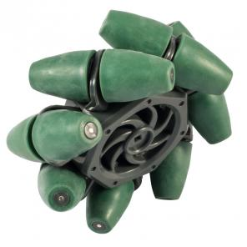

Mecanum wheel

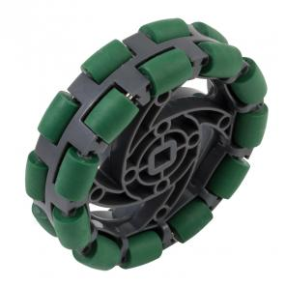

Omni-wheel

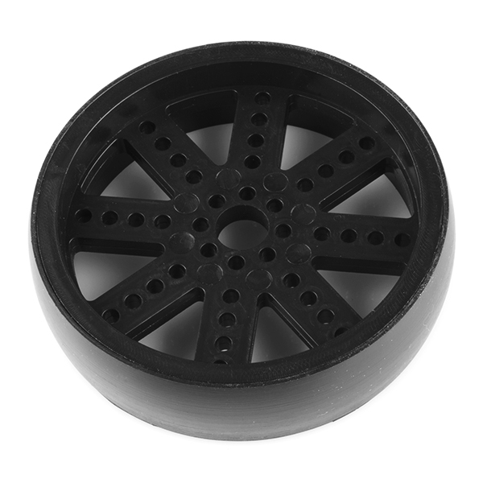

Heavy duty wheel